Estimating Option Price based on Black-Scholes-Merton Model and Double Exponential Jump Model - Based on AAPL Stock

Situ Ma

Contents

1. Introduction 3

1. Data description 4

2. Using historical variance to estimate option price 5

3. Calculate implied volatility based on Black-Scholes-Merton model 8

4. Predict option price using SVM 11

5. Double Exponential Jump Model 12

6. Possible Improvements 13

7. Conclusion 13

References 15

Appendices 16

# Introduction

Black-Scholes-Merton (BSM) model is popular in the pricing of options and other financial derivative instruments. Given stock price, maturity, volatility, interest rate and dividend, the model can be used to calculate the price of an option. And given the market price of options, we can use it to estimate market volatility without considering specific investor characteristics such as risk tolerance. It is also very useful in hedging the risks of financial assets. However, there are some limitations of the BSM model. In the original BSM model, there is an assumption that the volatility, dividend and risk-free rate are constant. But in reality, these terms in the model are hard to predict and may not be constants. Moreover, the stock price return is assumed to follow lognormal distribution. But in the real market, the distribution is usually left-skewed (because of transaction cost) (Teneng, D., 2011). Hence, jump model is implemented to improve the BSM model.

Jump model is first introduced in 1976 by Robert Merton. It considered the “crash” scenarios in the market. One of the reasons of “jumps” is that people may overreact to news. It may better describe the price movement of stocks.

There are three parts in the research. In the first part, we investigated the historical volatility in the BSM model. Historical volatility is calculated based on stock historical price movements. This volatility is used in the BSM model to calculate the option price. The calculated option prices are compared with the real option prices to see the difference.

In the second part, based on known market option prices, we calculated the implied volatility through the inverse function of the BSM model equation. And we used the 5-minute stock data to predict the next 1-minute stock price using the interpolated volatilities through SVM method.

In the third part, to overcome the disadvantages of BSM model, jump model is used to calculate the option price. And the predicted option prices are compared with real price to test the predictability of the model.

# Data description

The data we used is the Apple stock option transaction history on March 20, 2018 of NASDAQ. It contains trading time, option trade price, strike price, option style, call and put style and underlying stock trade price. There are 20211 records of the trading history of the day. The option underlying stock is Apple stock. But the strike price and the maturity of the options are different. There are 18 different maturities (from 1-week to 27-month’s maturity) and 58 strike prices (from 40 to 300). And there are both call and put options.

Below are the of the important variables and their symbols that will be used in the later research:

* $S_{t}$: current stock price
* $K$: option strike price
* $σ$: volatility of stock ( $σ^{2}$ is the variance)
* $T$: maturity of the option
* $r$: interest rate (risk-free rate)
* $N$: the number of data

Here we assume the interest rate or risk-free rate is zero for the calculation simplicity.

# Using historical variance to estimate option price

In the BSM model, it is easy to get the underlying stock price, strike price, maturity and other information in the market. But volatility is the unknown variable to be calculated using other information. In the first stage, we use the historical volatility as the volatility variable in the BSM model.

Given stock price, we can calculate the log return of the stock. And the standard deviation of the log return is the historical volatility $\hat{σ}$. $R_{t}$ is the log return of the stock at time t. $\overline{R}$ is the mean of the log return.

$${\hat{σ}}^{2}=\frac{1}{N}\sum_{t=1}^{N}{{\left(R_{t}-\overline{R}\right)}^{2}}$$

$$R_{t}=log⁡(\frac{S_{t}}{S_{t-1}})$$

We used the historical stock price data (March 20, 2017 to March 20, 2018 AAPL stock close price data from Yahoo finance) to calculate the volatility. We tried three different time frames: weekly, monthly and yearly. All these variances are annualized.

Based on BSM model, the call option price is:

$$C\left(S_{t},t\right)=N\left(d_{1}\right)*S_{t}-N\left(d_{2}\right)*K*e^{-r*(T-t)}$$

$$d_{1}=\frac{1}{σ\sqrt{T-t}}[\ln\left(\frac{S_{t}}{K}\right)+\left(r+\frac{σ^{2}}{2}\right)*(T-t)]$$

$$d_{2}=d_{1}- σ\sqrt{T-t}$$

And the put option price is:

$$P\left(S_{t},t\right)=N\left(-d_{2}\right)*K*e^{-r*\left(T-t\right)}-N\left(-d_{1}\right)*S_{t}$$

Here, N(x) is the cumulative distribution function of standard normal distribution.

We can calculate the option price based on the data given in the table and above information (difference is the estimated option price minus real option price).

**Table 2.1**

|  |  |  |  |  |  |  |
| --- | --- | --- | --- | --- | --- | --- |
| **Timeframe** | **Historical Volatility** | **Mean of difference** | | **Variance of difference** | | **MSE** |
| **Weekly** | 0.0893 | | -1.5867 | 3.9694 | 6.4869 | | |
| **Monthly** | 0.1904 | | -0.5599 | 0.6586 | 0.9721 | | |
| **Yearly** | 0.1964 | | -0.4860 | 0.5513 | 0.7874 | | |

The following graphs are the difference of the estimated option price and market option price (for yearly, monthly and weekly volatility).

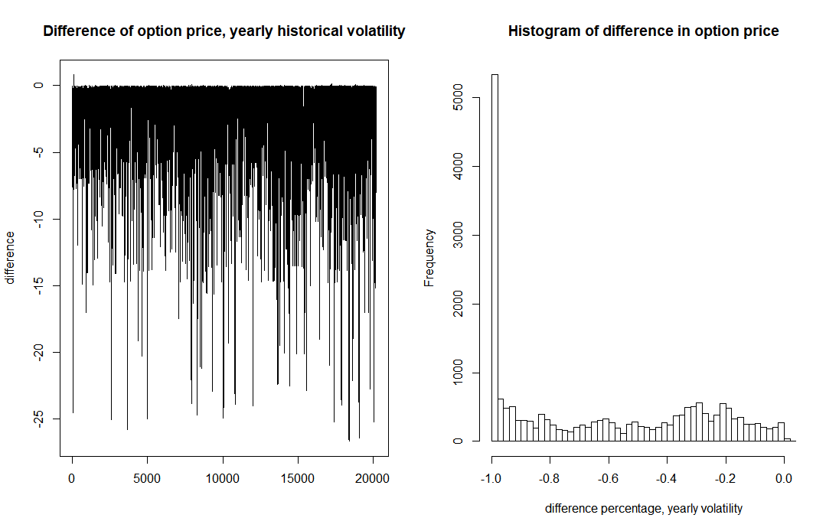

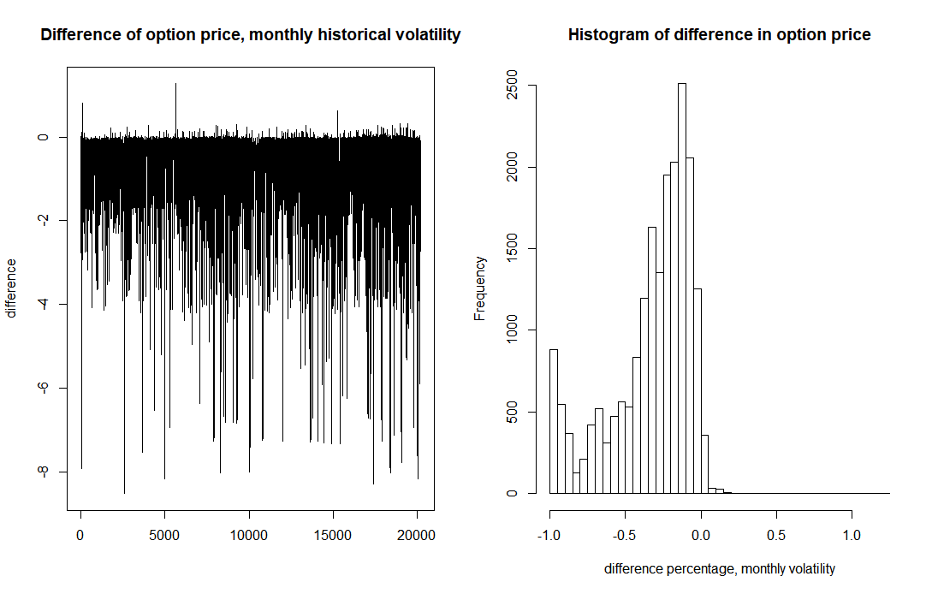

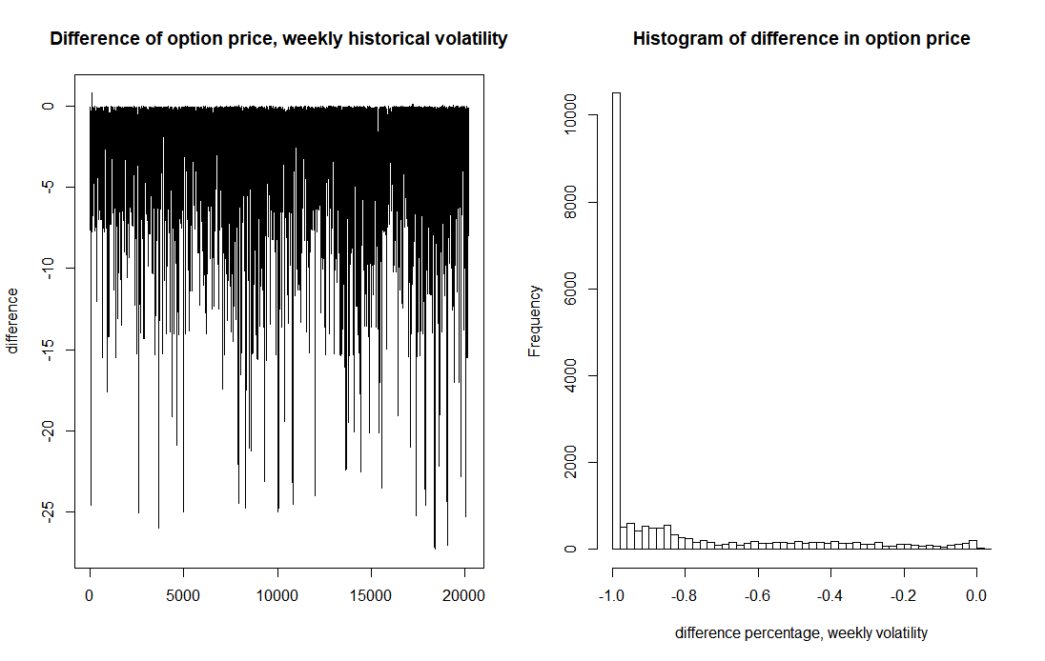

To better see the difference between market option price and estimated price, we calculated the number of overestimate and underestimate of option price for each trade record using yearly, monthly and weekly volatilities as below (total 20211 records):

**Table 2.2**

|  |  |  |  |  |  |  |  |  |  |
| --- | --- | --- | --- | --- | --- | --- | --- | --- | --- |
|  | **Threshold 10%** | | | **Threshold 5%** | | | **Threshold 1%** | | |
|  | **yearly** | **monthly** | **weekly** | **yearly** | **monthly** | **weekly** | **yearly** | **monthly** | **weekly** |
| **Overestimate number** | 244 | 33 | 0 | 499 | 67 | 0 | 1067 | 277 | 1 |
| **Overestimate percentage** | 1.21% | 0.16% | 0.00% | 2.47% | 0.33% | 0.00% | 5.28% | 1.37% | 0.00% |
| **Underestimate number** | 14831 | 16474 | 19564 | 17102 | 18529 | 19780 | 18628 | 19584 | 20080 |
| **Underestimate percentage** | 73.38% | 81.51% | 96.80% | 84.62% | 91.68% | 97.87% | 92.17% | 96.90% | 99.35% |

We can see that all the three volatilities cannot give a very precise estimation of the real option price even at the 10% threshold. The historical volatilities mostly underestimated the market option price. Among the three results, the yearly historical volatility is slightly better than the other two.

# Calculate implied volatility based on Black-Scholes-Merton model

As we can see from the results, historical volatility is not a good estimator of the volatility in the Black-Scholes-Merton model. Firstly, it is a constant value. As we analyzed before, the volatility should not be constant. Secondly, it is backward-looking. The historical cannot represent future. Therefore, in the second stage we calculated implied volatility to estimate the option price.

Historical volatility is a backward-looking estimator as it is based on historical data while implied volatility is forward-looking. Implied volatility represents the expected fluctuations of the underlying asset in the future time frame. Option traders often use both historical volatility and implied volatility to test whether the option price is overvalued or undervalued. If implied volatility is lower than historical volatility, the option price is likely to be undervalued and vice versa.

Implied volatility can be a better estimator. It is the calculated using the market option price. The BSM model shows how to calculate option price using stock price, strike price, maturity, volatility and interest rate. If we put the market option price into the equation, we can calculate the volatility for the given option price. This is called implied volatility.

$$Implied Volatility=F(S_{t},K,T,t,r,option price)$$

The following graph is the histogram and fitted density distribution line. We can see that the implied volatilities are mostly centered at the mean 0.24448 (annualized). The variance of implied volatility is 0.002212.

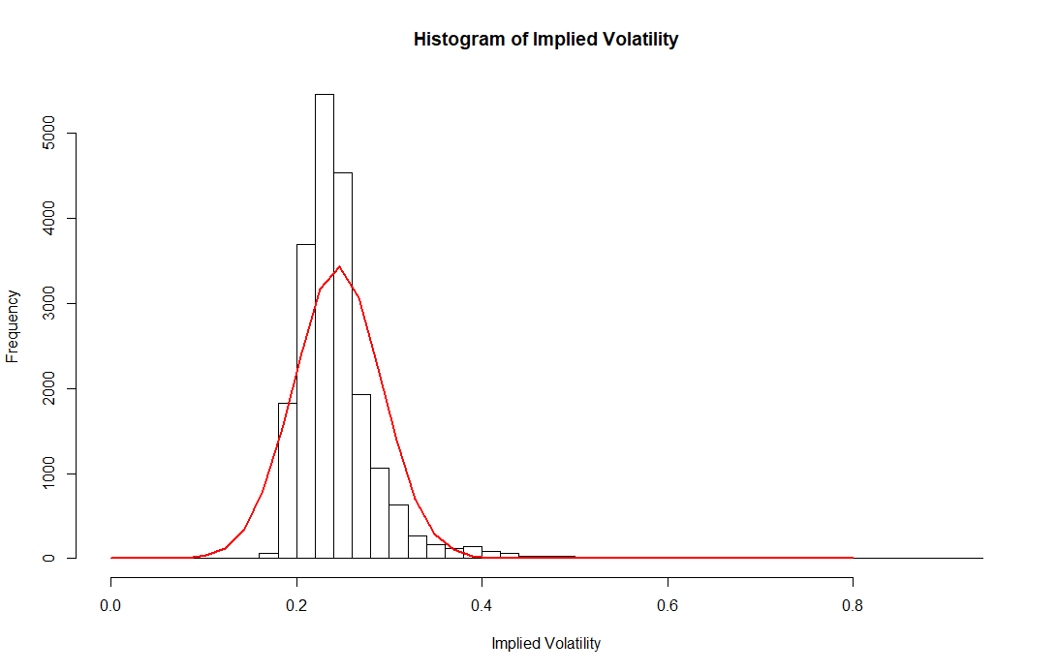

We can see that the historical volatility is lower than the implied volatility calculated here. This may indicate that the market option price is overvalued.

We plotted the strike price and implied volatility at different maturities using spline interpolation (see appendix zip file). We can find that most of the implied volatility plots satisfy the “volatility smile”. Volatility smirk a common graph shape of strike price and implied volatility. The volatility increases when the option price is in the money or out of the money. It is because most of the options are traded near the at the price case (strike price equal to stock price). There may be greater demand than supply for the in the money and out of the money cases. So, these options are likely to be overvalued, and thus have higher volatility.

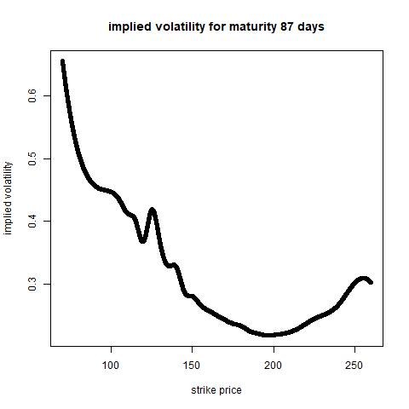

And for in the money calls or out of the money puts, they are more expensive because of the risk averse feature of the investors. They are worried about the market crashes and buying out of the money puts for protection.

The following is the 3-D implied volatility graph. X-axis is the strike price, Y-axis is the maturity and Z-axis is the implied volatility. The shape of the graph also satisfies “volatility smirk”. The implied volatility is lowest when the strike price approaches the market price (around 160) of the stock.

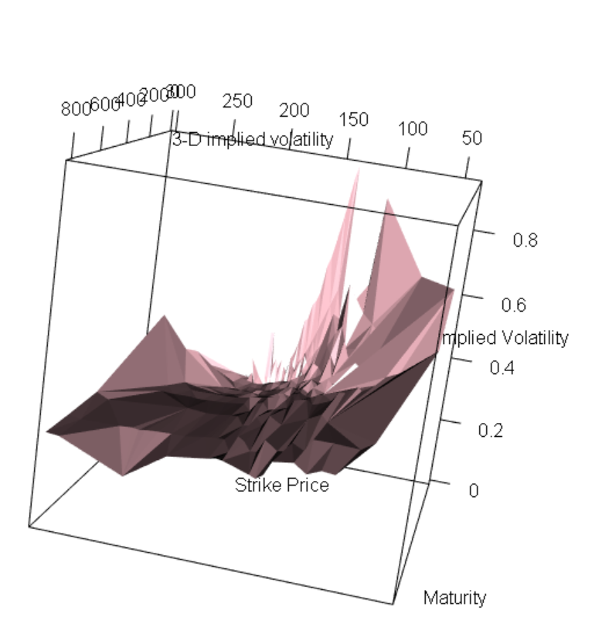

# Predict option price using SVM

To see whether implied volatility is a better estimator and its predictability of the future volatility, we use the SVM method and 5-minute data to predict the future 1-minute option price. And use the calculated option price to compare with the real data to see whether the interpolated volatility can finely estimate the future option price.

To test the predictability of implied volatility, we used the SVM model to estimate volatility in the future based on historical dat. And calculate the option price using the estimated volatility.

SVM is Support Vector Machines. This method takes the train data as input to figure out a multi-dimension surface that can separate the data points to different groups. Here we use the strike price and maturity as input and use the model to predict the implied volatility for a given strike price and maturity option in the future time.

In this stage, we split the daily transaction records into different groups. One kind of the group is train data (5-minute data) and the other is test data (1-minute data). We used the 5-minute data to train the machine. The SVM model helped to estimate the volatility in the future 1 minute.

The estimation results are in the appendices. Below shows the predicted price and market price difference of group 2.

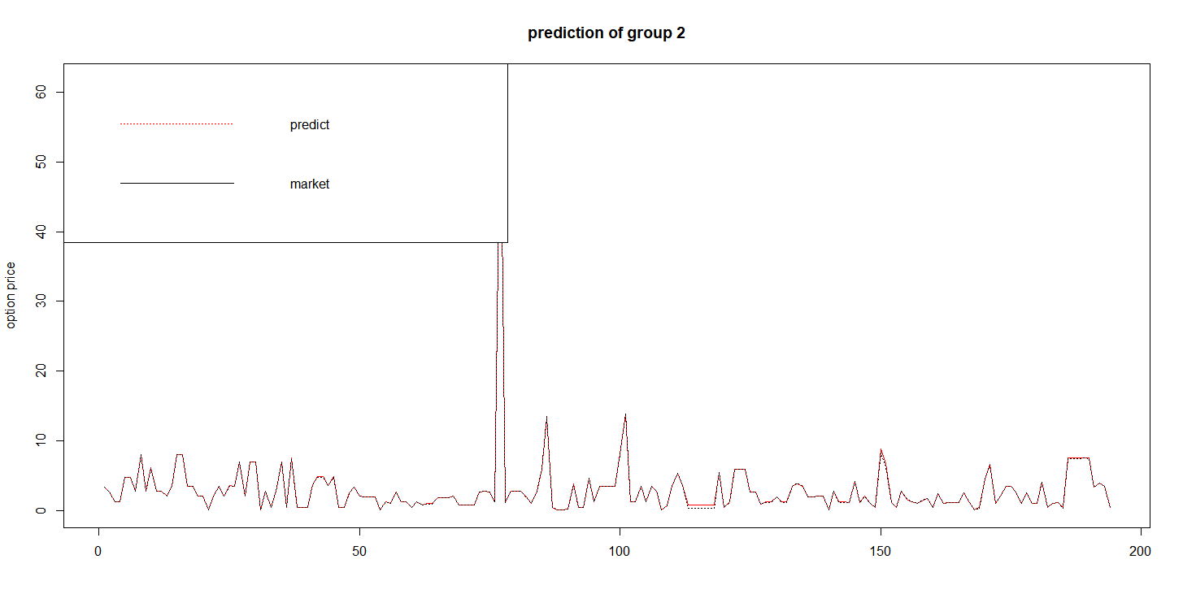

We found that the SVM model can correctly estimate the option price 90% of the time over setting the threshold 10% (the threshold is the estimated option price percentage difference with the market option price).

# Double Exponential Jump Model

Here we used the Double Exponential Jump Diffusion Model (DEJD) to improve the estimation of option price.

DEJD was firstly put forward by Steven Kou. This model is a compromise between reality and tractability. It explains the asymmetric leptokurtic feature and the volatility smile.

In this model, the dynamics of stock price is given by:

$$\frac{dS_{t}}{S_{t-}}=μdt+σdW_{t}+d(\sum_{i=1}^{N_{i}}{e^{Y_{i}}}-1)$$

It is similar to the BSM model except the diffusion term $d(\sum_{i=1}^{N_{i}}{e^{Y_{i}}}-1)$. The $Y_{i}$ is jump size and are i.i.d. with asymmetric double exponential distribution of density:

$$f_{Y}\left(y\right)=pη_{1}e^{-α^{+}y}1_{\{y≥0\}}+qη_{2}e^{-α^{-}y}1_{\{y<0\}}$$

Here the p and q are the probability of jump up and jump down, p+q=1. $α^{+}>1$ is imposed to ensure the stock price has finite expectation. $α^{+}$ and $α^{-}$ are the parameters of the two exponential distributions (Kou, 2004). They are also the expected positive and negative jump sizes. $α$ is the mean of log jump size.

The characteristic function of the model is:

$$φ_{T}\left(u\right)=\exp\left\{iuwT-\frac{1}{2}u^{2}σ^{2}T+λT(\frac{p}{α^{+}-iu}-\frac{q}{α^{-}+iu})\right\}$$

Here, $w=-\frac{1}{2}α^{2}-λ(\frac{p}{α^{+}+1}-\frac{q}{α^{-}-1})$.

Given the characteristic function of the DEJD model, we can use the Fast Fourier Transform to get the distribution of stock price.

Then we can use the sampling method such as importance sampling to get the sampled stock price. The stock price can later be used to calculate the option price. Use the Monte Carlo method and calculate the option price for many times we can get the expected option price for given strike price, maturity and other variables and parameters in the model (Andreevska, I., 2008)).

However, we are unable to figure out a set of feasible parameters for the DEJD model. This part is remained to be investigated in the future.

# Possible Improvements

Firstly, the data we used in this research is the AAPL option trading records for a day. We can further analyze other stocks data and for a longer timeframe to generalize the findings.

Secondly, we did not customize the parameters and functions of the SVM model. Although the current estimation result is satisfactory, it can still be improved in the future by using different functions and parameters.

Moreover, we did not manage to implement the jump model in the option price estimation because it is kind of tricky to find out the feasible parameters for the model. But it could improve the prediction precision if successfully implemented.

# Conclusion

In this research, we used BSM model to estimate option price using different volatilities. Historical volatility is the volatility of stock in the history. It is a constant value, which is in line with the BSM model’s assumption. Implied volatility is the forward-looking volatility calculated from the option price. The two volatilities are used and compared in the option pricing. We found that the implied volatility can provide a much better estimation of the option price. This may be due to the forward-looking feature of it. And historical volatility may also be affected by the historical market events which may not exist today. Implied volatility only considers the current market and current sentimental of the market, which is obviously more feasible.

# References

Teneng, D. (2011). Limitations of the Black-Scholes model. *Collection of Papers 2011–Volume I*, 143.

Lewis, A. L. (2001). A simple option formula for general jump-diffusion and other exponential Lévy processes. *Available at SSRN 282110*.

Kou, S. G., & Wang, H. (2004). Option pricing under a double exponential jump diffusion model. *Management science*, *50*(9), 1178-1192.

Andreevska, I. (2008). Mathematical modeling and analysis of options with jump-diffusion volatility.

Gatheral, J. (2010). Jump‐Diffusion Models. *Encyclopedia of Quantitative Finance*.

# Appendices





